Hemispherical Sector
# Source: AI Source: Provided by: [Data Path: Persons Table -> ID Column: 1, Name_En Column: Motasem Essam] -> From: [ChatGPT] on [7/25/2026]
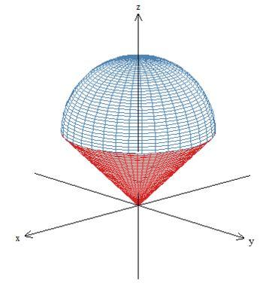

Definition
# Source: AI Source: Provided by: [Data Path: Persons Table -> ID Column: 1, Name_En Column: Motasem Essam] -> From: [ChatGPT] on [7/25/2026]
A hemispherical sector is a spherical sector associated with a hemisphere. A spherical sector consists of a spherical cap together with the cone-shaped solid connecting the cap's circular boundary to the center of the original sphere.
When the cap is hemispherical, its cutting plane passes through the sphere's center, so the cap height equals the sphere radius. The corresponding spherical sector occupies half the sphere's volume.
Terminology note: Hemispherical sector is less standardized than spherical sector and hemisphere. Here, it means the spherical sector formed from a hemispherical cap.

Simple Definition
# Source: AI Source: Provided by: [Data Path: Persons Table -> ID Column: 1, Name_En Column: Motasem Essam] -> From: [ChatGPT] on [7/25/2026]
A hemispherical sector is the solid formed by a hemispherical cap and the cone-shaped region joining its circular edge to the center of the sphere.

Geometric Elements
# Source: AI Source: Provided by: [Data Path: Persons Table -> ID Column: 1, Name_En Column: Motasem Essam] -> From: [ChatGPT] on [7/25/2026]
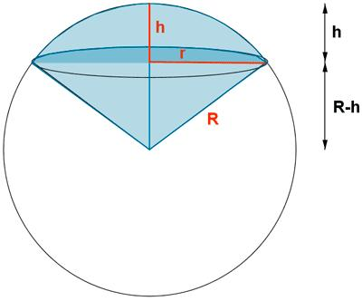
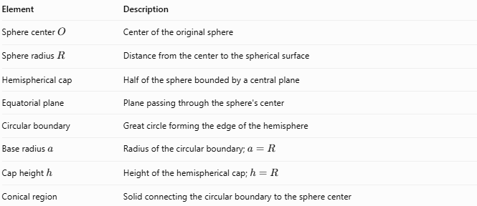
Element | Description
Sphere center $O$ | Center of the original sphere
Sphere radius $R$ | Distance from the center to the spherical surface
Hemispherical cap | Half of the sphere bounded by a central plane
Equatorial plane | Plane passing through the sphere's center
Circular boundary | Great circle forming the edge of the hemisphere
Base radius $a$ | Radius of the circular boundary; $a=R$
Cap height $h$ | Height of the hemispherical cap; $h=R$
Conical region | Solid connecting the circular boundary to the sphere center

Mathematical Properties and Formulas
# Source: AI Source: Provided by: [Data Path: Persons Table -> ID Column: 1, Name_En Column: Motasem Essam] -> From: [ChatGPT] on [7/25/2026]
Let $R$ be the sphere radius, $h$ the cap height, and $V$ the sector volume.

Height and Radius
# Source: AI Source: Provided by: [Data Path: Persons Table -> ID Column: 1, Name_En Column: Motasem Essam] -> From: [ChatGPT] on [7/25/2026]
Because the cap is hemispherical:
$$\boxed{h=R}$$
The circular boundary is a great circle, so its radius is also
$$\boxed{a=R}$$

Volume of the Spherical Sector
# Source: AI Source: Provided by: [Data Path: Persons Table -> ID Column: 1, Name_En Column: Motasem Essam] -> From: [ChatGPT] on [7/25/2026]
The general spherical-sector volume formula is
$$V=\frac{2}{3}πR^{2}h$$
For a hemispherical sector, $h=R$. Therefore,
$$\boxed{V=\frac{2}{3}πR^{3}}$$
This is half the volume of the original sphere.

Curved Surface Area
# Source: AI Source: Provided by: [Data Path: Persons Table -> ID Column: 1, Name_En Column: Motasem Essam] -> From: [ChatGPT] on [7/25/2026]
The curved hemispherical surface area is
$$\boxed{A_{c}=2πR^{2}}$$

Flat Circular Face Area
# Source: AI Source: Provided by: [Data Path: Persons Table -> ID Column: 1, Name_En Column: Motasem Essam] -> From: [ChatGPT] on [7/25/2026]
$$\boxed{A_{b}=πR^{2}}$$

Total Surface Area of the Hemisphere
# Source: AI Source: Provided by: [Data Path: Persons Table -> ID Column: 1, Name_En Column: Motasem Essam] -> From: [ChatGPT] on [7/25/2026]
Including the flat circular face:
$$\boxed{A_{t}=3πR^{2}}$$
The conical surface is an internal geometric boundary used to describe the sector's construction; it is not an additional external face of the hemispherical solid.

Worked Example
# Source: AI Source: Provided by: [Data Path: Persons Table -> ID Column: 1, Name_En Column: Motasem Essam] -> From: [ChatGPT] on [7/25/2026]
A hemispherical sector is formed from a sphere of radius $R=6\text{ cm}$. Calculate its volume, curved surface area, and total surface area.
Given
$$R=6\text{ cm}, h=R=6\text{ cm}$$
Step 1 — Calculate the sector volume
$$\begin{aligned}V&=\frac{2}{3}{πR}^{3} \\ &=\frac{2}{3}π\left(6^{3}\right) \\ &=144π\end{aligned}$$
$$\boxed{V≈452.39{\text{ cm}}^{3}}$$
Step 2 — Calculate the curved surface area
$$A_{c}=2πR^{2}=2π\left(36\right)=72π$$
$$\boxed{A_{c}≈226.19{\text{ cm}}^{2}}$$
Step 3 — Calculate the total surface area
$$A_{t}=3πR^{2}=3π\left(36\right)=108π$$
$$\boxed{A_{t}≈339.29{\text{ cm}}^{2}}$$

Comparison with Related Solids
# Source: AI Source: Provided by: [Data Path: Persons Table -> ID Column: 1, Name_En Column: Motasem Essam] -> From: [ChatGPT] on [7/25/2026]
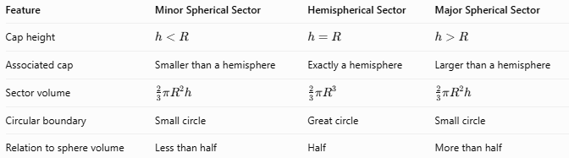
Feature | Minor Spherical Sector | Hemispherical Sector | Major Spherical Sector
Cap height | $$h<R$$ | $$h=R$$ | $$h>R$$
Associated cap | Smaller than a hemisphere | Exactly a hemisphere | Larger than a hemisphere
Sector volume | $$\frac{2}{3}πR^{2}h$$ | $$\frac{2}{3}πR^{3}$$ | $$\frac{2}{3}πR^{2}h$$
Circular boundary | Small circle | Great circle | Small circle
Relation to sphere volume | Less than half | Half | More than half

Applications
# Source: AI Source: Provided by: [Data Path: Persons Table -> ID Column: 1, Name_En Column: Motasem Essam] -> From: [ChatGPT] on [7/25/2026]
- Geometry: Understanding spherical sectors and their relationship to hemispheres.
- Engineering: Calculating the volume of hemispherical components.
- Architecture: Modeling hemispherical domes and curved structures.
- Manufacturing: Estimating material requirements for hemispherical parts.
- Computer graphics: Representing hemispheres and their associated spherical sectors.

Key Points
# Source: AI Source: Provided by: [Data Path: Persons Table -> ID Column: 1, Name_En Column: Motasem Essam] -> From: [ChatGPT] on [7/25/2026]
- A hemispherical sector is defined here as the sector associated with a hemispherical cap.
- The cutting plane passes through the sphere's center.
- Its cap height and circular boundary radius both equal the sphere radius.
- Its volume is half the volume of the original sphere.
- The hemisphere's external surface consists of a curved surface and one flat circular base.
- The conical region describes the sector's construction; it is not an additional external face of the hemisphere.

Conclusion
# Source: AI Source: Provided by: [Data Path: Persons Table -> ID Column: 1, Name_En Column: Motasem Essam] -> From: [ChatGPT] on [7/25/2026]
A Hemispherical Sector is the spherical sector associated with a hemisphere, formed by a hemispherical cap and the region connecting its circular boundary to the sphere's center. Its defining relationship is \(h=R\), giving a volume equal to half the original sphere's volume.

